11 Online Resources To Learn HTML5 Development for beginners

With all the buzz of new programming languages like Swift, Python, Hadoop, etc. emerging in this web world, HTML5 still remains the loudest buzzwords in web industry. With its constant growth and intensifying browser support, this technology is not going to lose its fame anytime. Even if you are a beginner or advanced level programmer in HTML5, you will have to remain updated with its latest features as well as maintaining its previous compatibility.
Check out the survey conducted on HTML5 developers, when asked for “what is the reason they find HTML5 more appealing to use for web development?”
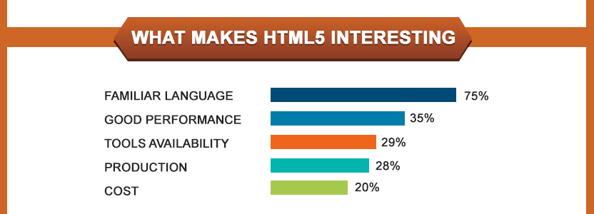

Here are some benefits of HTML5 which can be useful for any HTML5 developers.
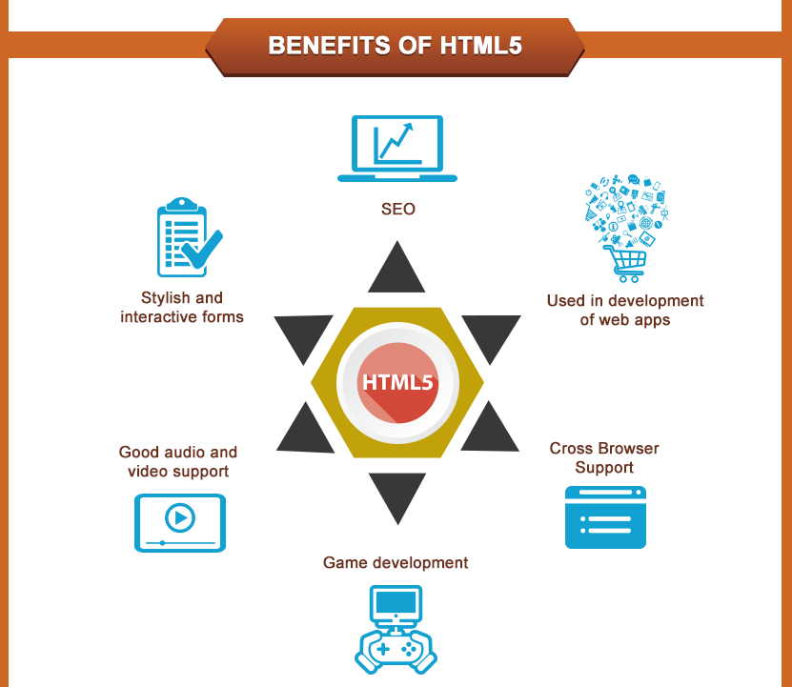

In a research conducted by trends.builtwith, almost 8.6% of websites use HTML5 in some form or other. Also I have mentioned top sectors which are using HTML5 in their websites.
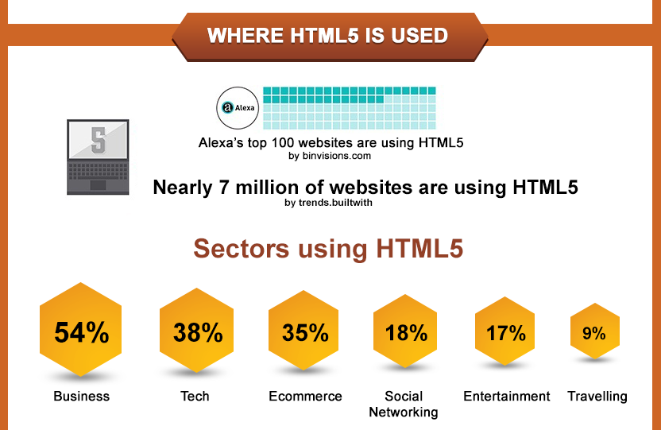

In this world map you can see the usage of HTML5 by regions. You can easily predict the popularity of this language by looking at their percentages. In US its around 70% and in most of the countries its over 50%.
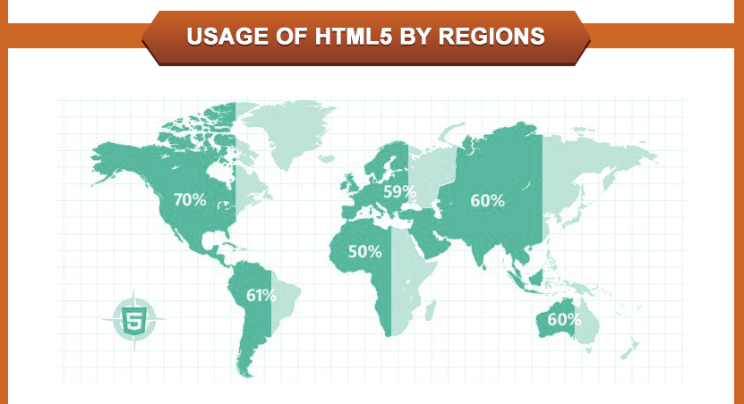

If the current growth rate of HTML5 continues by 2022 HTML5 will be everywhere and most used technology over the web. See below how it climbed way over mighty Everest
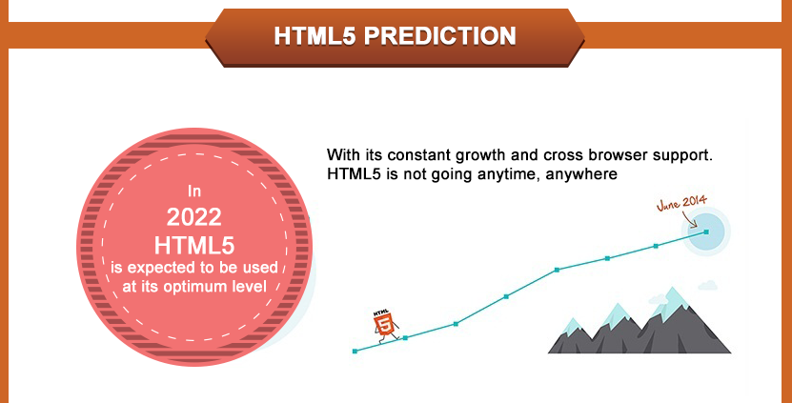

Gone are the days when there were limited resources to learn HTML5 programming in a university through books or eBooks. Nowadays internet has gone beyond boundaries to gain knowledge in effective way with minimum efforts. More and more people are turning towards online platforms to gain knowledge in programming languages like HTML5 where you will get lot to blogs, video tutorials, forums which can help you to learn programming in best way.
Just by exploring in Google you can find hundreds of effective results to learn HTML online. But with a lot of choices available on the web it can be too confusing and time consuming for you to choose the best place to start learning this awesome technology. So here is the list of 11 best resources which we have picked up for you to help you learn HTML5 and get a better grip on it. We have categorized these resources to help you choose according to your need.

Websites and Blogs Where You Can Learn HTML5
While exploring for where to start learning HTML5, I found thousands of results for eBooks, web-guide, tutorials but I have handpicked the best websites and blog sites where you can start of to learn HTML5 from basic. If you are a beginner and know nothing about HTML5 then you must definitely head on to these websites. Here you will get basic tutorials, articles and blogs on HTML5 and not only coding but you will also find good examples along with it to learn HTML5 in simple steps. Check out these website below to get started.
1) W3Schools
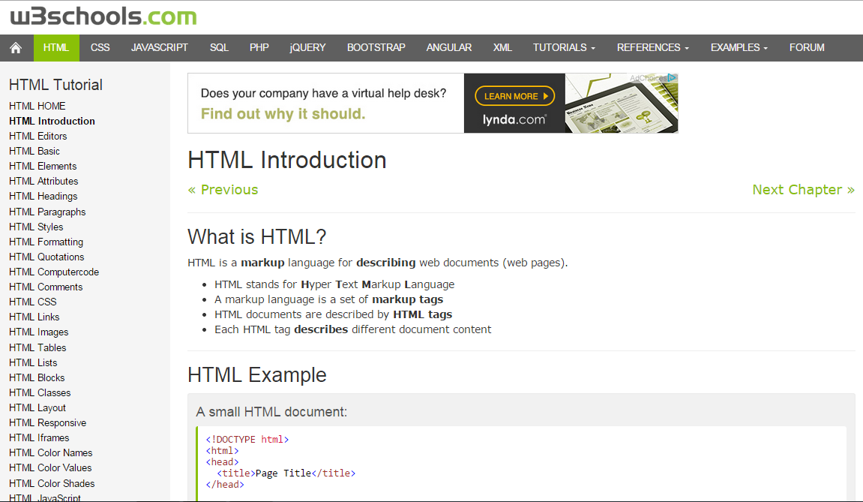
One of the best resource for learning HTML5, W3School has excellent tutorials on HTML5, with examples, solved practically, that you can yourself try it. If you want to learn HTML5 form basics, then you are at right place. You will learn all elements of HTML such as tags, images, graphics and what not just by following the steps shown in tutorials which are explained in simple language and are interactive.
2) htmlgoodies
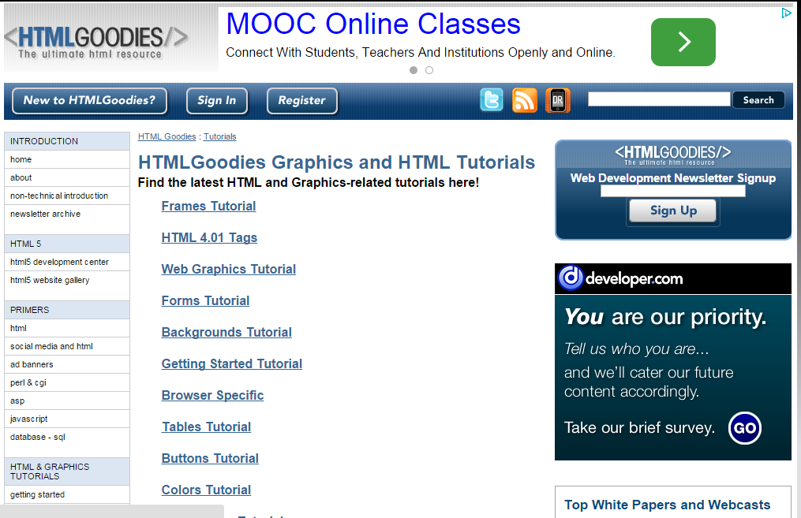
If you are a beginner and want a crash course on HTML5 to quickly gain knowledge about all features of HTML5, then htmlgoodies is a great place to start upon. You can see the sections on the left side which are categorized into basics, tutorials, question and answers, beyond HTML where you can quickly jump to any section of your choice and start learning.
3) HTML5-tutorial
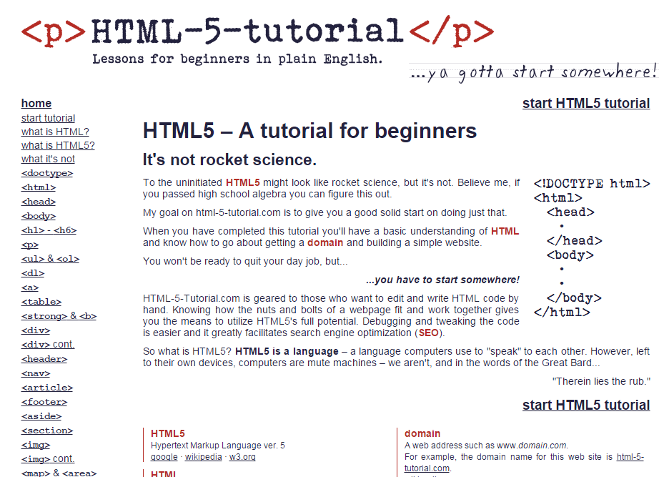
If you are a beginner in HTML5 and want a solid start in a short time, then HTML5 tutorials is a good resource to start. Here you will get a basic understanding and knowing HTML, building a website, editing and debugging code just to know nut and bolts regarding HTML5 and the website.
4) HTML5 Doctor
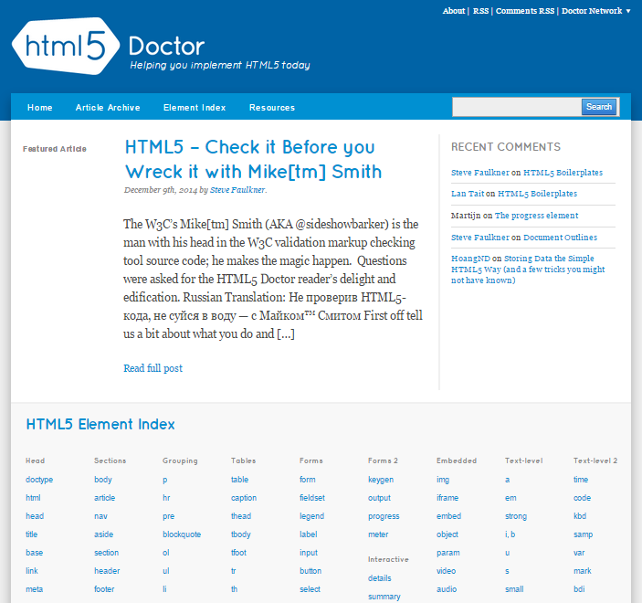
Everything you want to start with HTML5, you must definitely head over to HTML5 Doctor. Here you will get all articles which will help you to learn more on why’s and how’s of implementing HTML5. One interesting thing about HTML5 Doctor is that you will find “Ask the Doctor” section in which you can get all your doubts cleared by experts.
5) html5rocks
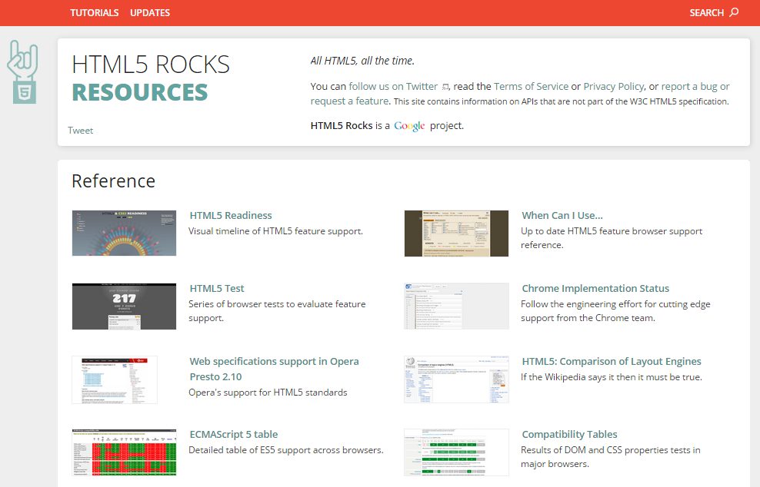
Developers who are looking to implement HTML5 in website and carry out any R&D with HTML5 coding HTML5 rocks is seriously an awesome resource. Here you will get all information on features of HTML5 and when and how to implement in making website or app.

Free Online Video Course For HTML5
Shifting from tutorials and guides we will move towards Online Video tutorials on HTML5. Structured lessons and videos will help you to remain engaged and grasp more learning. These websites have good quality videos, exercises, forums and certification after completion of course to keep student interactive while learning. Check out below websites which I have found out to help you learn basic HTML5 for free by learning at your own pace.

6) Alison
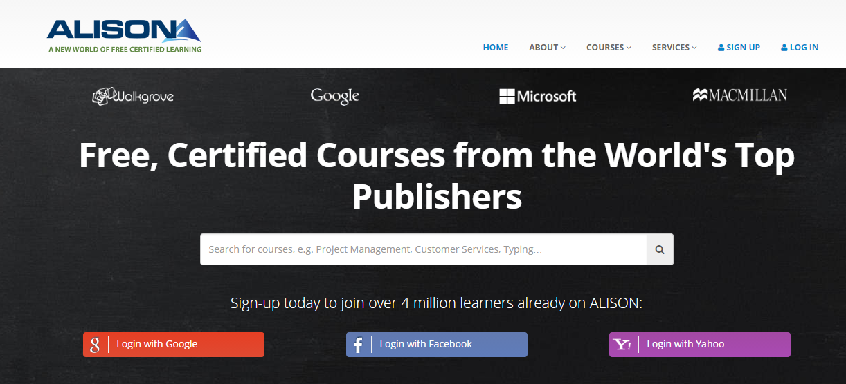
Alison is one of the good online platform to learn HTML5 for free. In this website you will learn HTML5 courses step by step to design, build and publish pages on web. You will get High quality videos with 1 to 2 hrs duration to learn HTML5 at your own pace with certification.

7) Udacity
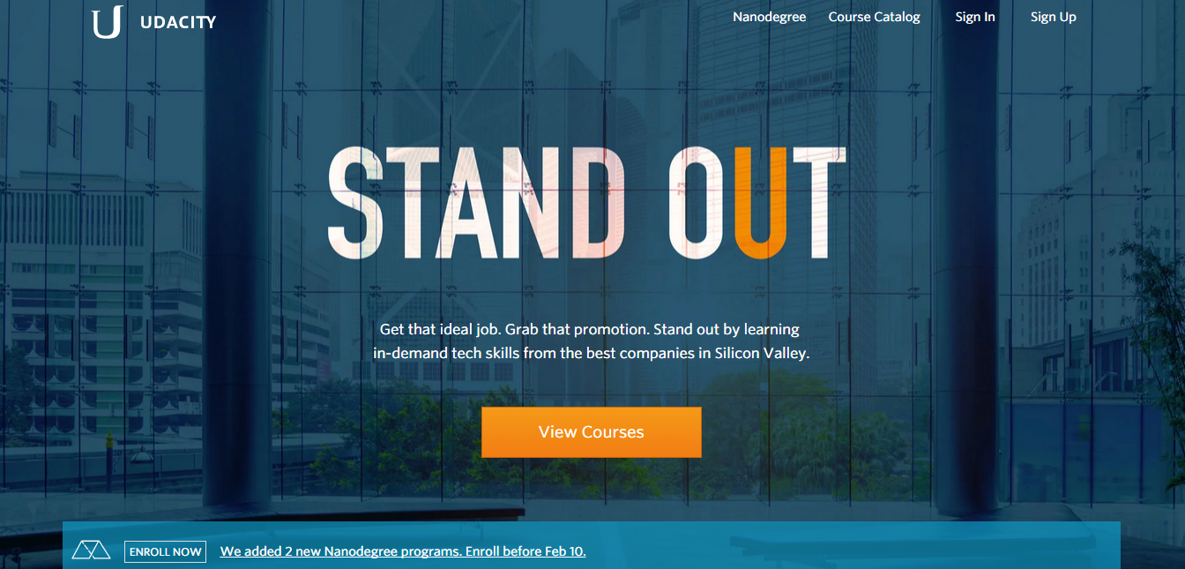
Another good platform where you will find free HTML5 canvas and game development course for beginners as well as for intermediate level. You will also earn certificate after completion of these courses.

8) thenewboston
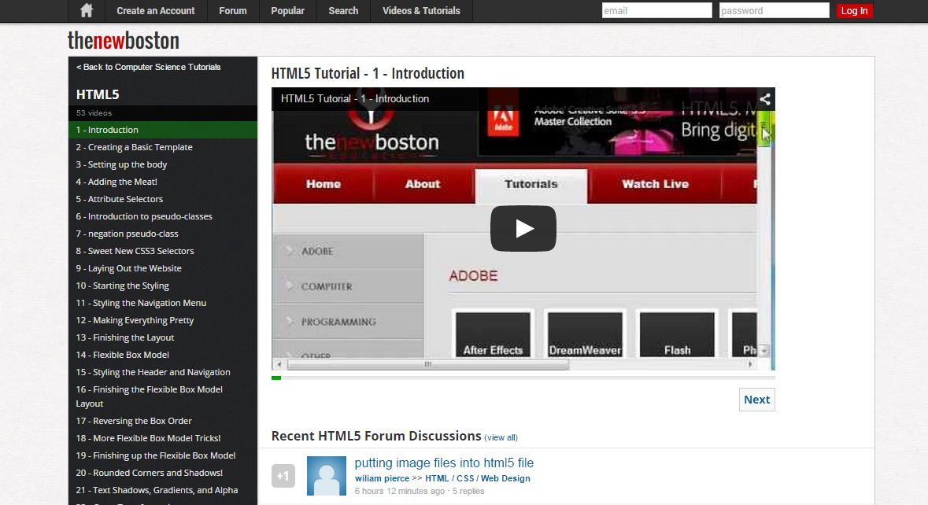
Thenewboston is another place where you will find free video tutorials on HTML5. This website has good collection of programming video courses like Adobe, java, C++ which are divided into sections. You can find HTML5 programming in Computer Science section. You will get few tutorials on HTML5, Canvas, Video player which you can learn it for free.

Advanced Tutorials to Learn HTML5 Programming Online
After having basic and ground knowledge about HTML5 coding through free tutorials, blogs, websites, now it’s time to get deep into HTML5 coding skills with these advanced video tutorials on HTML5. After a lot of research I have found out these website where you can learn advanced HTML5 with projects, quizzes, apps with high end coding on HTML5. You will definitely feel you are doing some serious development work while learning these tutorials. So go ahead and check it out.

9) Eduonix
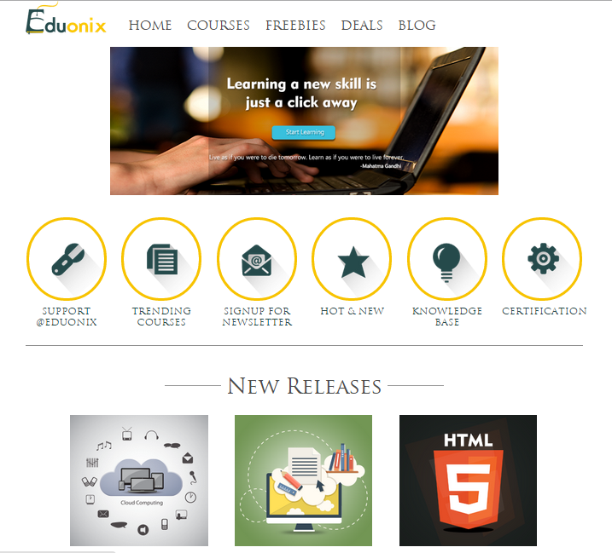
We would really miss Eduonix if I don’t mention it on this topic to learn HTML5. An excellent online platform where you will find all web development and mobile development technologies under one umbrella. Eduonix’s Projects in HTML5 programming course is a great resource for developers to advance their HTML skills by learning HTML5 with 10 projects and quizzes. Interactive video lectures with great examples will help you to master yourself in HTML5 development.

10) Udemy
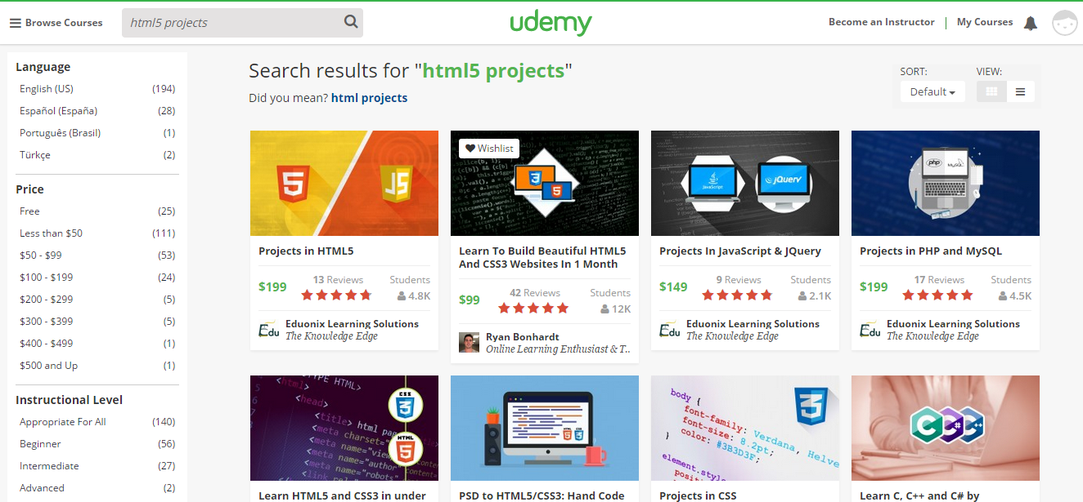
One of the best online platform for all types of programmers who want to learn HTML5 and also other programming languages. Here you will get to learn HTML5 through interactive videos with certificate of completion of course. You can find project based HTML5 course in Udemy to advance your skill in web designing. You only need to sign up at Udemy and enrol for the course and enjoy video lectures.

11) Webucator
Here you can move on to advanced training in HTML5 by joining live training classes, private training, group training and also self-paced course. Although you have to pay a bit high for registration, but for sure, you won’t regret it after completing classes.
I hope you have found our article helpful to provide you the best places to learn HTML5. Please let us know if we have missed out any other platform to grip your skills on HTML5.

